**A Node-Red node to pass point data into Geo SCADA**

S Beadle, 6-4-17, 12/4/17, 23/4/17, 17/7/17, 20/06/18, 2/06/19, 22/07/2020

**Install Node-Red on Windows**

**Install Node**

<https://nodered.org/docs/getting-started/installation>

Click ‘Windows’ link. Click link to ‘Node.js home page’. Install Windows (x64) LTS version.

**Install Node-Red**

Start Node.js command prompt from Start menu (as Admin)

npm install -g --unsafe-perm node-red

and

npm install -g --unsafe-perm xml2js

(Do not try on SE network or VPN – will not work, use external connection.)

**Start Node-Red**

*> node-red*

Check you have access to the UI at http://localhost:1880

Press-Ctrl-C to stop in order to:

**Add the Geo SCADA node**

<https://nodered.org/docs/creating-nodes/>

Place the files from the Box folder here into:

C:\Users\<your user id>\AppData\Roaming\npm\node_modules\node-red\nodes

This will add GeoSCADA.html and .js into this folder, and add an icon into an icons subfolder.

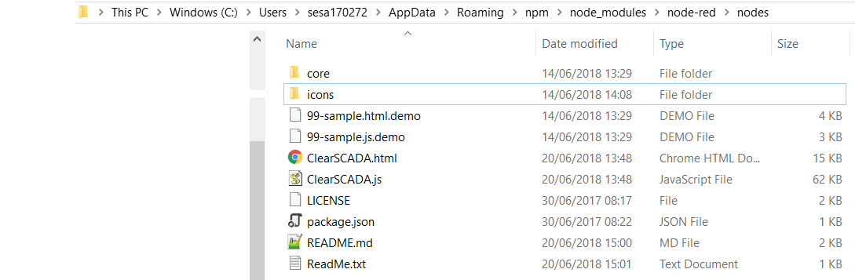

Restart Node-red.

**Try it out:**

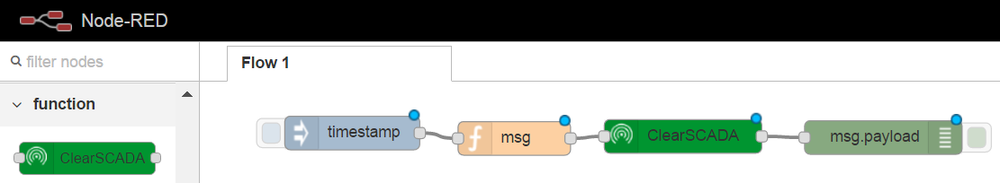

**In Function ‘msg’**

msg.topic = "my point full name"

msg.time = msg.payload // Set time from the payload of the manual injection

msg.payload = 2.71 // Set point value

**In Geo SCADA node**

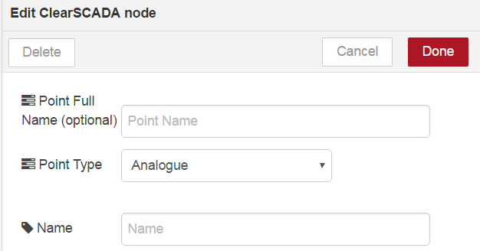

Click on the server to define a (common) server node name and port. Enter username and password in the connection page. The HTTPS option will only work with a fully signed certificate.

Select Point type to match all points being processed by this node.

The Point Full Name param is optional. If left blank this will be fed in as the Topic name.

Points are Internal (‘Hand dressed’).

**How it works**

The Geo SCADA node uses a SOAP HTTP request on the ClearSCADA server to call the Hand Control function of an internal point.

**Other functions**

Use the GeoSCADA Get Object node to get summary data about an object. For example, when using a point name, the data includes Current Value, Time, Quality etc.

Use the GeoSCADA Read Query node to execute any SQL query and return the results to node-red.

